PRACTICAL LIST – AY: 2026- 27
Sr. no. | Title
10. | Title: Mobile Security Testing using Appium  Aim: To perform security-oriented testing of an Android application by  verifying authentication, permissions, session management, and secure data  handling using Appium.  Software/Tools Required  ● Appium  ● Android Studio  ● Android Emulator / Android Device  ● Appium Inspector  ● Python/Java  ● Internet Connection  Procedure  1. Install Appium and configure the Android Emulator or a real Android  device.  2. Launch the selected Android application using Appium.  3. Verify user authentication by testing valid and invalid login  credentials.  4. Check access control by attempting to access restricted screens  without authentication.  5. Validate application permissions such as Camera, Storage, and  Location.  6. Test session management by logging out and verifying that protected  pages cannot be accessed using the Back button.  7. Record the observations and document any security issues identified.  Expected Outcome: The security features of the Android application, including authentication, authorization, permissions, and session management, are successfully verified.  Result: Mobile security testing was successfully performed using Appium,  and the application&#39;s security features were validated.
Step-1: Install Android Studio – Download and install Android Studio on the system to obtain the Android SDK and required Android automation tools.
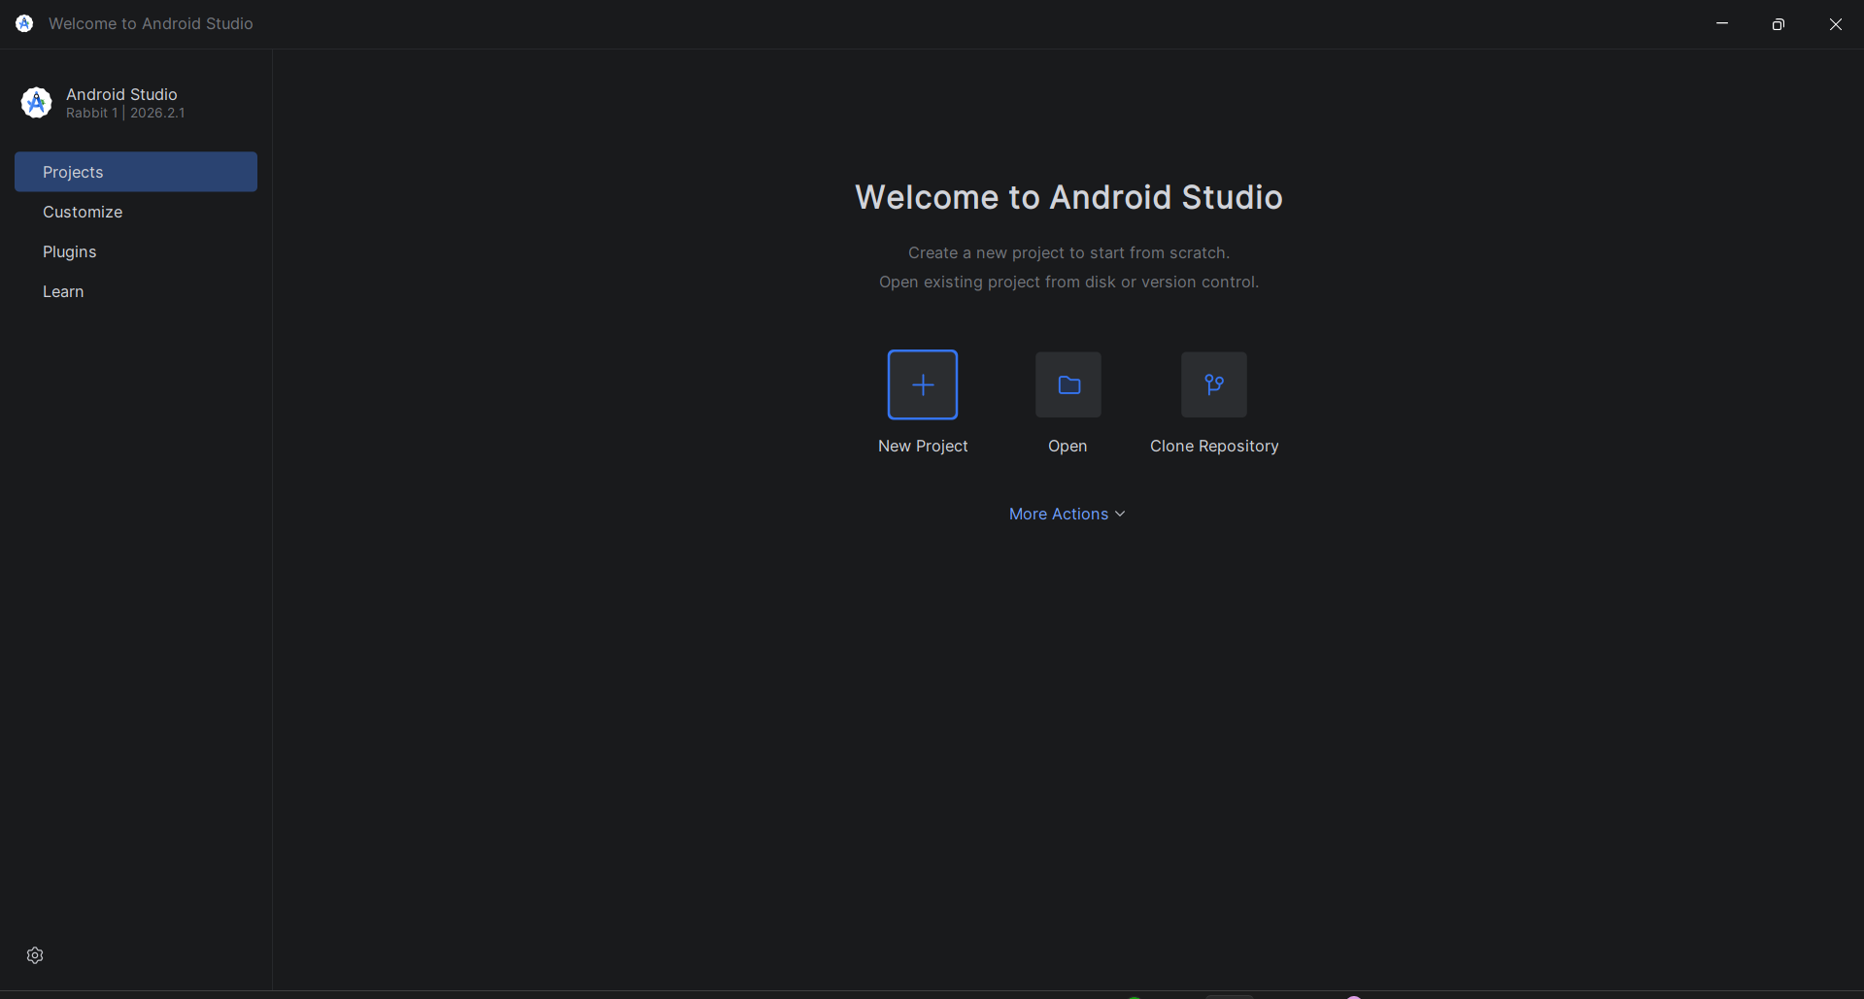
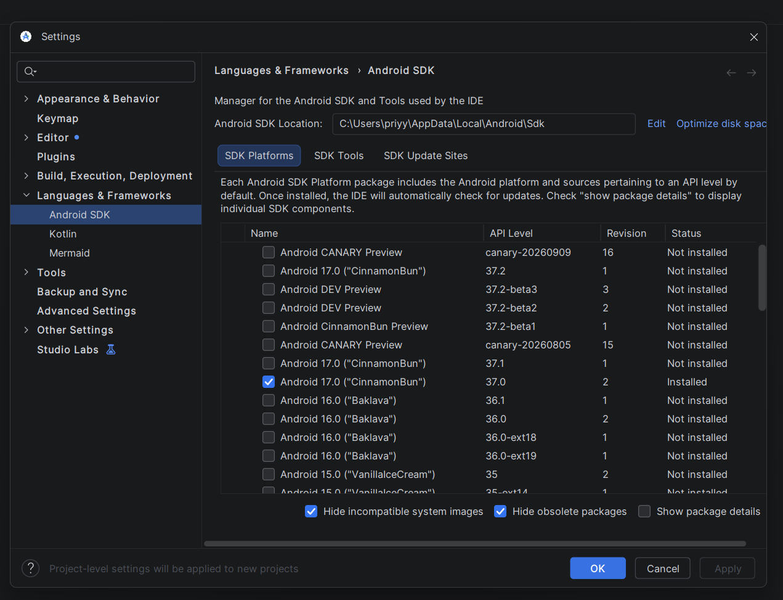
Step-2: Open SDK Manager – Launch Android Studio and open Configure → SDK Manager to manage the Android SDK platforms and tools.
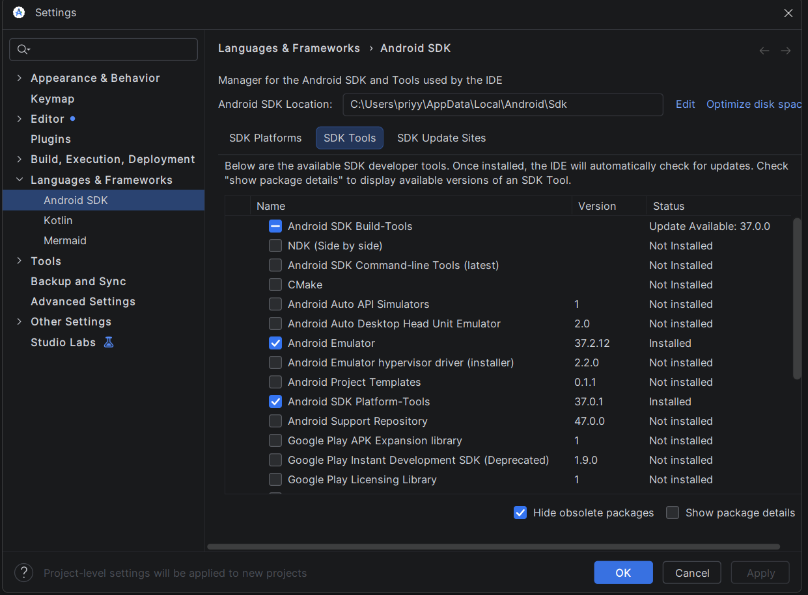
Step-3: Install an SDK Platform – In SDK Platforms, select the required Android API version and install it on the system.
Step-4: Install SDK Tools – Open the SDK Tools tab and install the required Android tools, including the platform and emulator tools needed for automation.
Step-5: Configure ANDROID_HOME – Set the ANDROID_HOME environment variable to the location where the Android SDK is installed.
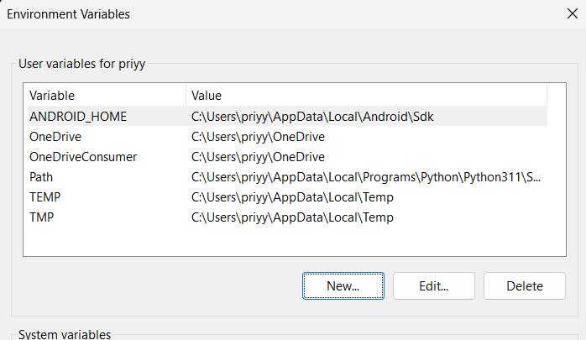
Step-6: Configure Android SDK PATH – Add the Android SDK emulator, tools, tools/bin, and platform-tools directories to the system PATH so that Android commands can be executed from the terminal.
Step-7: Reload Environment Variables – On macOS/Linux, reload the shell configuration using the appropriate source command after modifying the environment variables.
Step-8: Verify ADB – Open Terminal or Command Prompt and execute adb to verify that Android Debug Bridge is installed and available.
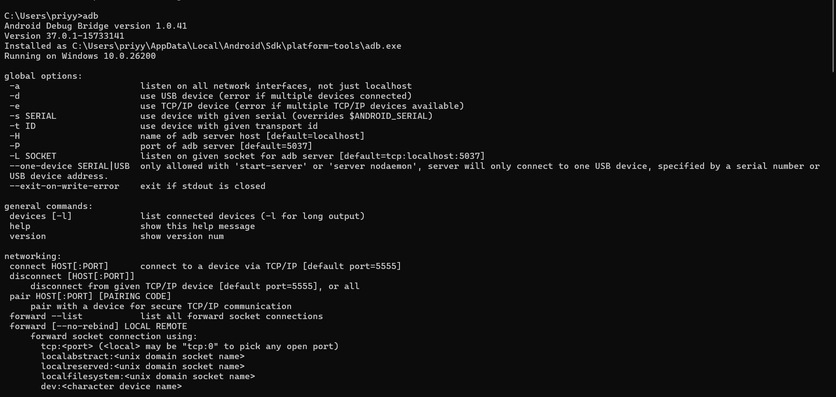
Step-9: Open AVD Manager – Open Android Studio and select Configure → AVD Manager to create an Android virtual device.
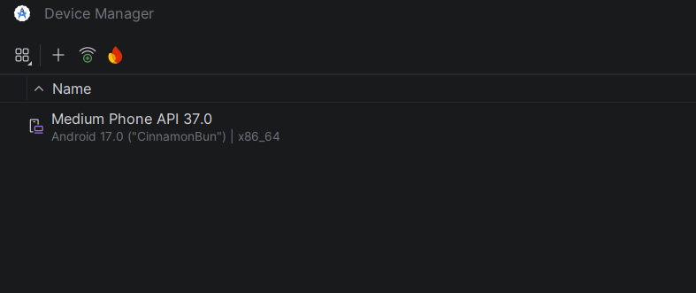
Step-10: Create a Virtual Device – Click Create a Virtual Device to start the Android Virtual Device configuration process.
Step-11: Select the Device Type – Select a device category such as Phone, Tablet, or TV, and choose an appropriate device model and screen configuration.
Step-12: Select a System Image – Select the required Android version and download the system image if it is not already installed.

Step-13: Name the Virtual Device – Enter a meaningful AVD name, such as Automation, and complete the virtual-device configuration.
Step-14: Start the Emulator – In AVD Manager, click the Play button under the Actions section to start the configured Android emulator.
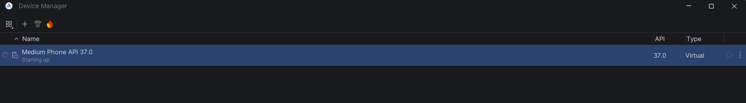
Step-15: Connect a Real Android Device (Optional) – If a physical device is used instead of an emulator, connect the Android device to the computer using a USB cable.
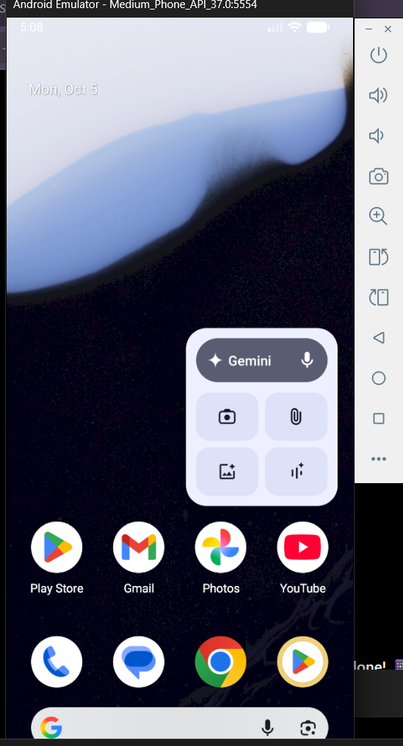

Step-16: Enable Developer Mode – Open About Phone on the Android device and tap Build Number repeatedly until Developer Options are enabled.
Step-17: Enable USB Debugging – Open Developer Options and enable USB Debugging to allow ADB and Appium to communicate with the physical device.
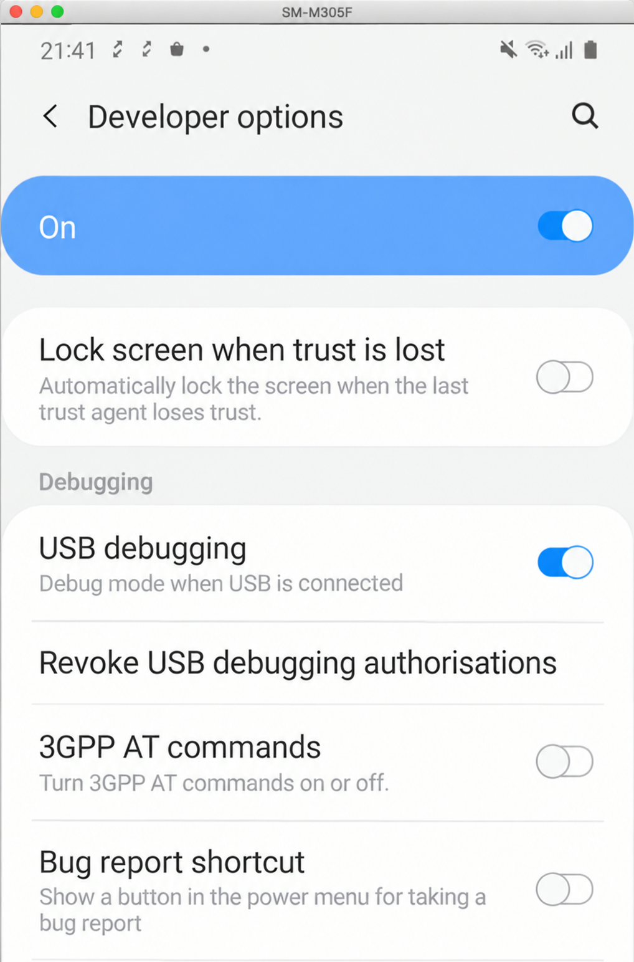

Step-18: Verify the Android Device – Execute adb devices in the terminal and verify that the emulator or physical Android device is listed.
Step-19: Install Appium Inspector – Download and install the Appium Inspector desktop application suitable for the operating system.

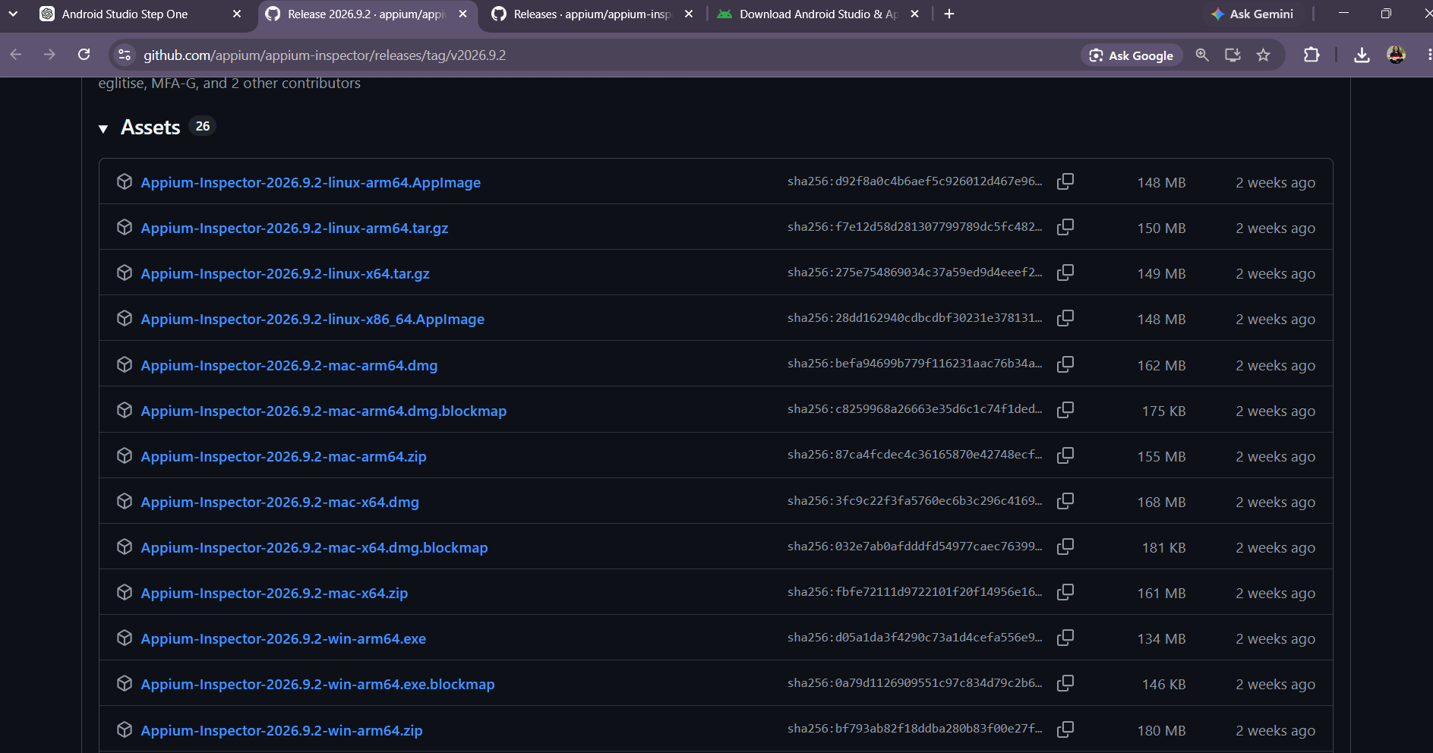
Step-20: Launch Appium Inspector – Open Appium Inspector after installation; on macOS, allow the application to open through the system security settings if a security warning is displayed.
Step-21: Prepare the Appium Application – Ensure that the Android application to be tested, such as the Appium API Demos application, is available and note its absolute file path.
Step-22: Open Desired Capabilities – In Appium Inspector, locate the Desired Capabilities → JSON Representation section where the Android session configuration can be entered.
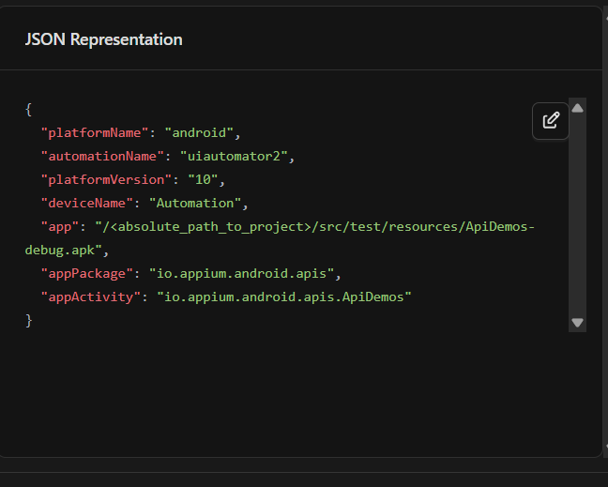
Step-23: Configure Android Capabilities – Enter the Android platform, automation engine, Android version, device name, application path, package name, and activity in the capabilities configuration.
Step-24: Update the Application Path – Replace the sample application path in the app capability with the absolute path of the APK being tested.
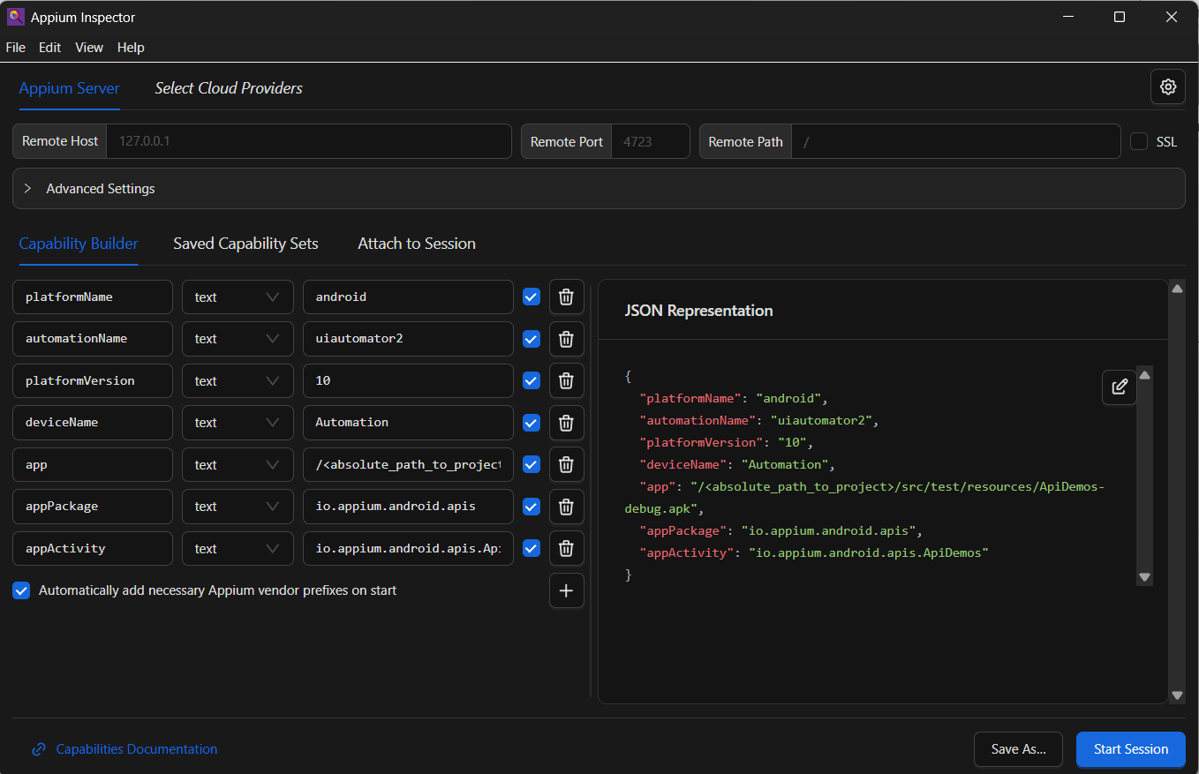
Step-25: Save the Capabilities – Save the configured capabilities in Appium Inspector and use Save As to store the configuration with a meaningful name for future testing.
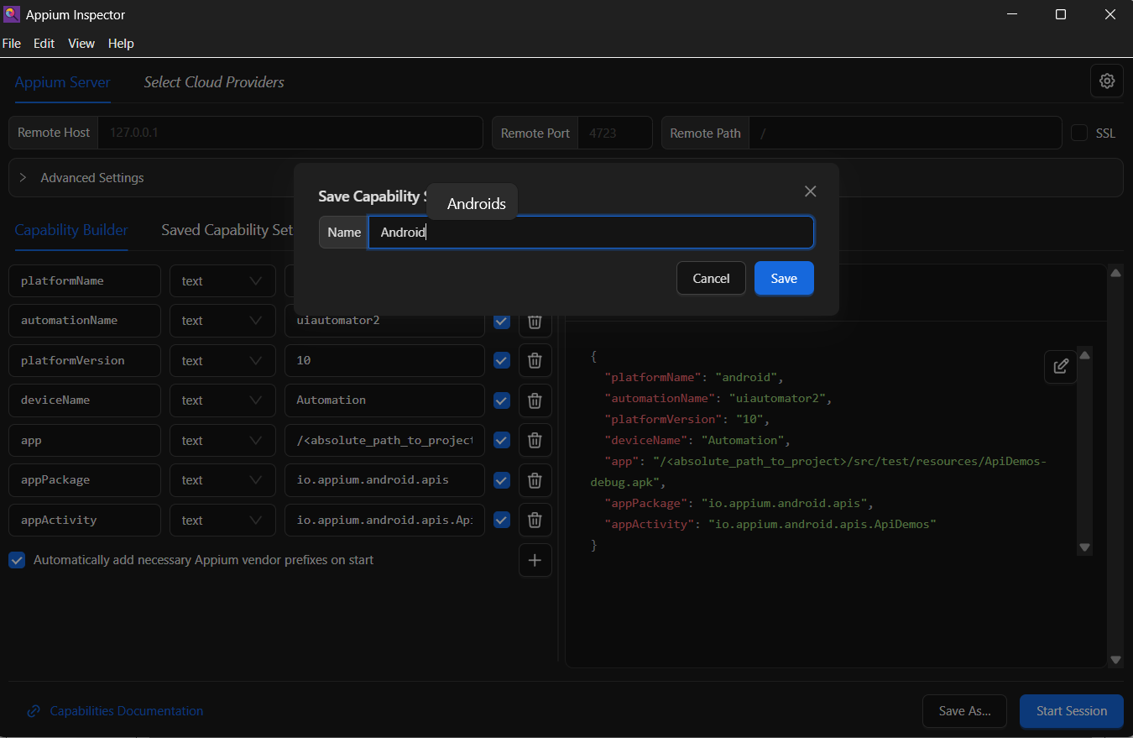
Step-26: Start the Appium Server – Open Terminal or Command Prompt and execute the appium command to start the local Appium server.
Step-27: Verify the Appium Server – Confirm that the Appium server starts successfully and provides the local REST interface, normally on port 4723.
Step-28: Ensure the Android Device is Running – Verify that the emulator is fully booted or that the physical Android device is connected before creating the Appium session.
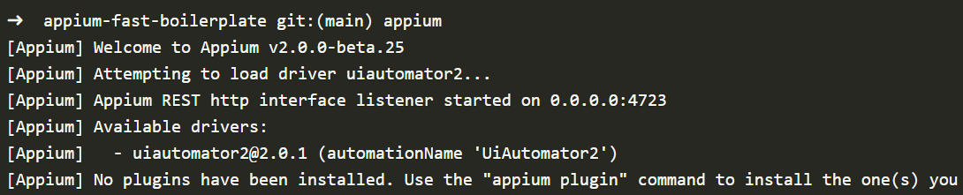
Step-29: Start the Inspector Session – In Appium Inspector, use the configured server and capabilities and click Start Session to establish an Appium session with the Android application.
Step-30: Verify Application Launch – Confirm that the API Demos application launches successfully and that the Inspector displays the application's interface.
Step-31: Inspect Application Elements – Select UI elements in Appium Inspector and examine their element hierarchy and properties to identify suitable locators for automation.
Step-32: Create the Android Automation Project – Create or open the Java-based Appium automation project and organize the source code into test, page-object, driver, utility, and configuration components.
Step-33: Define the Test Objective – Design the test using the Arrange-Act-Assert approach so that it opens the API Demos application, navigates to Log Text Box, taps Add, and verifies the displayed log text.
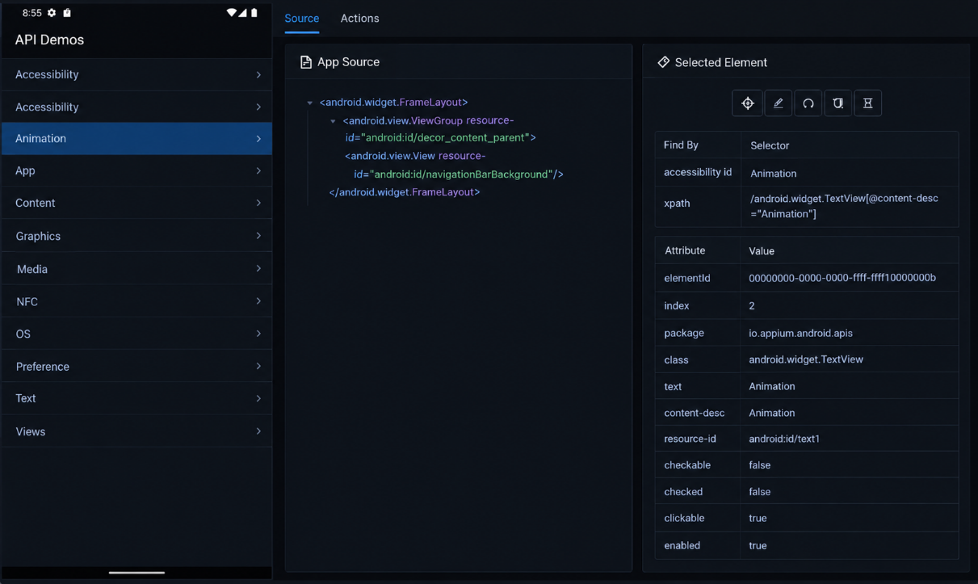

Step-34: Create the Android Test Class – Create AndroidTest and extend BaseTest so that common driver setup and teardown operations are reused by the test.
Step-35: Implement the Test Flow – Implement the test so that it opens the Text section, navigates to Log Text Box, taps the Add button, and retrieves the displayed text.
Step-36: Add the Test Assertion – Compare the retrieved log text with the expected value "This is a test" using an assertion.
Step-37: Create the Base Test Class – Create BaseTest with a protected AppiumDriver and initialize the driver before each test using the configured target and DriverManager.
Step-38: Configure Test Teardown – Add an @AfterMethod teardown method that calls driver.quit() after the test finishes to close the Appium session.
Step-39: Create the Driver Manager – Create DriverManager to select the appropriate driver based on the target platform and load the corresponding capabilities configuration.
Step-40: Configure the Appium Server URL – Set the local Appium server URL to http://127.0.0.1:4723 in the driver configuration.
Step-41: Create the Android Driver – Load the Android capabilities configuration and use it to create an AppiumDriver connected to the local Appium server.
Step-42: Create the Application Page Object – Create an APIDemosHomePage class that extends BasePage and represents the application's home screen.
Step-43: Define UI Locators – Define the required application element locators, such as the Text and LogTextBox elements, using Appium-compatible By locators.
Step-44: Implement Page Actions – Implement methods such as openText() and tapOnLogTextBox() to perform the required application interactions.
Step-45: Apply the Fluent Pattern – Return the current page or the next page object from page-action methods so that multiple application actions can be chained together in the test.
Tutorial | https://www.youtube.com/watch?v=dVTZpsNINM8

